MALAWI SUSTAINABLE DEVELOPMENT NETWORK PROGRAMME

l l l l l l l l l  M A L A W I  S D N P  i  Coordinator  P.B.T. Nyirenda, B.Sc., M.S., Ph.D.  No : mwsdnp/quote/ |  | Malawi SDNP, Polytechnic,  Private Bag 303, Chichiri, Blantyre 3, MALAWI  Tel: +265 875872 / 874979 / 824787  Fax: +265 873 944
26th August 2010 |  | e-mail:accountant@sdnp.org.mw

Attention: Geof Chirwa-TNM

.mw DOMAIN NAME SERVICE QUOTATION

Service | Cost/month | Period | Amount
.mw domain name service: Covers the first 2 years. The annual renewal charge is $50.00 |  | 2 years | $100.00
Total in USD |  |  | $100.00
Total in MK using exchange rate for January 2010 : $1.00 = MK152.2936 |  |  | MK15229.39

Make payment in Malawi Kwacha to Malawi SDNP.

For Malawi SDNP,
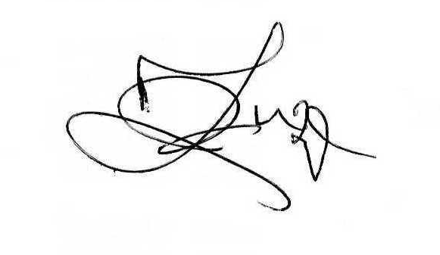
Francis Zuze

ASSISTANT ACCOUNTANT

